WEEK 3
Week Ending: 19-09-2025 |  | DAY: | Subject: Computing
Duration: 50mins |  |  | Strand: Introduction To Computing
Class: B8 |  | Class Size: | Sub Strand: Input & Output Devices.
Content Standard:  B8.1.1.1. Identify parts a computer and technology tools | Indicator:  B8.1.1.1.3. Examine the uses of the output devices: |  |  |  |  |  | Lesson:  1 of 2
Performance Indicator:  Learners can examine the uses of the output devices |  |  |  | Core Competencies:  Communication and Collaboration, Critical Thinking and Problem solving
Reference: Computing Curriculum Pg. 24
Activities For Learning & Assessment |  |  |  |  | Resources | Progression
Starter (5mins)  Revise with learners to review their understanding in the previous lesson.  Share performance indicators and introduce the lesson.  Main (35mins)  Revise with learners on some common output devices they know.  Ask groups to identify any four types of output devices and state its functions.  Guide learners to identify Braille printers, Impact, Inkjet, Thermal, Wax, 3D printers from pictures.  Guide learners to explore the features of these output devices.  Explore how these output devices work in real life situations.  Assessment:  State and explain three features of Braille printers, Impact, Inkjet, Thermal, Wax, 3D printers  Reflection (10mins)  Use peer discussion and effective questioning to find out from learners what they have learnt during the lesson.  Take feedback from learners and summarize the lesson. |  |  |  |  | Pictures and videos | Identifying and describing the features of the output devices.

Week Ending: 19-09-2025 | DAY: |  | Subject: Computing
Duration: 50mins |  |  | Strand: Introduction To Computing
Class: B8 | Class Size: |  | Sub Strand: Storage Systems
Content Standard:  B8.1.1.1. Identify parts a computer and technology tools |  | Indicator:  B8.1.1.1.4 Describe storage devices |  |  |  |  | Lesson:  1 of 2
Performance Indicator:  Learners can describe storage devices |  |  |  | Core Competencies:  Communication and Collaboration, Critical Thinking and Problem solving
Reference: Computing Curriculum P.g. 24
Activities For Learning & Assessment |  |  |  |  | Resources | Progression
Starter (5mins)  Revise with learners to review their understanding in the previous lesson.  Share performance indicators and introduce the lesson.  Main (35mins)  Guide learners to revise on the terminologies used in storage systems.  - Storage device- any mechanism capable of reading and writing information from and on a storage medium  - Storage medium- any physical material capable of holding information either temporarily or permanently and at the same time information can be retrieved from it  - Storage- holds items such as data, instruction and information  - Memory- a place in storage media / devices where information is read, written, stored and retrieved by the CPU  Guide learners to discuss the main storage devices of a computer and give examples.  - Primary Storage Memory and Secondary Storage Memory  Have learners’ research and discuss the Flash Memory Storage Systems.  Flash memory is an electronic non-volatile computer memory storage medium that can be electronically erased and reprogrammed.  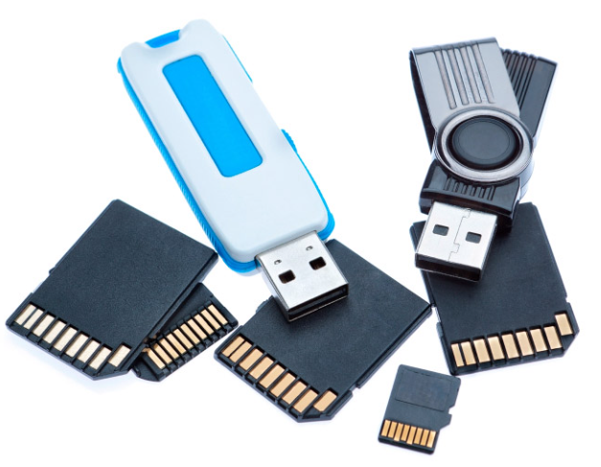  Demonstrate and illustrate the use of Flash Memory Storage Systems, Embedded Flash Memory, Flash Memory Cards and Readers, USB Flash Drives, Solid State Drives and Hybrid hard drives.  Guide learners to discuss the features of Flash Memory Storage Systems, Embedded Flash Memory Flash Memory Cards and Readers.  Assessment:  What is a storage device?  List 5 examples of storage device.  How does the Flash Memory Storage Systems work?  Reflection (10mins)  Use peer discussion and effective questioning to find out from learners what they have learnt during the lesson.  Take feedback from learners and summarize the lesson. |  |  |  |  | Pictures and videos | Illustrating the use of Flash Memory Storage Systems, Embedded Flash Memory, Flash Memory Cards and Readers, USB Flash Drives, Solid State Drives and Hybrid hard drives.

